WEEK 1 TASK: DATA CLEANING AND PRELIMINARY ANALYSIS REPORT

1. Project Overview
* Intern Name: Ananya Rastogi
* Role: Virtual R Data Analyst Intern
* Organization: YuvaIntern
* Dataset Used: Olist Customers Dataset (olist_customers_dataset.csv)

2. Introduction
For the Week 1 task, the Olist Customers Dataset was selected to perform basic data ingestion, structure inspection, and preliminary analysis using R Programming. The primary objective was to check the structure, generate summary statistics, and identify any missing values within the workspace environment.

3. R Code Implemented
The following clean R script was executed in the Posit Cloud console to perform the analysis:

data <- read.csv("olist_customers_dataset.csv")

print("--- DATA STRUCTURE ---")
str(data)

print("--- DATA SUMMARY ---")
summary(data)

print("--- MISSING VALUES COUNT ---")
sum(is.na(data))

4. Key Observations & Summary Statistics
* Data Dimensions: The dataset contains a total of 99,441 records tracking customer locations across Brazil.
* Geographical Distribution: Customers are mapped across 27 unique states (customer_state) and 4,119 unique cities (customer_city).
* Data Integrity: The execution of the sum(is.na(data)) function returned a result of 0, confirming that there are no missing values (NA values) present in the dataset.

5. Output Evidence
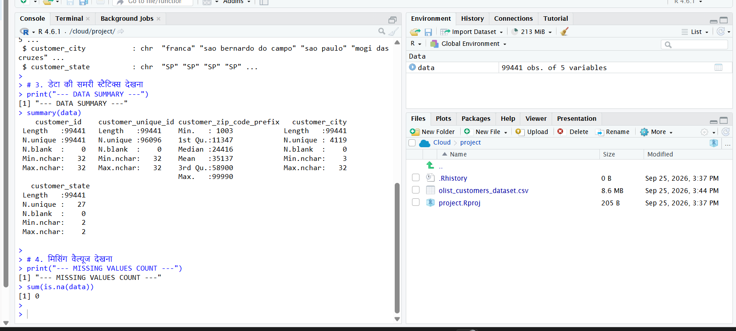
6. Conclusion
The data was successfully processed in the R environment. Preliminary operations such as structural validation and summary analysis confirm that the dataset is clean, structurally sound, and fully prepared for advanced predictive modeling or visualization in the upcoming weeks.

WEEK 2 TASK: DATA VISUALIZATION AND INSIGHT COMMUNICATION1. Introduction & Core ObjectiveThe primary objective of Week 2 is to transform the cleaned Olist E-commerce data into dynamic visualizations using the ggplot2 framework in R. This phase focuses on detecting operational patterns, customer sentiment distributions, and communicating technical trends into non-technical corporate narratives.The analysis is structured around key metrics: temporal sales tracking, category distribution, user sentiment metrics, and operational performance anomalies.

This line chart displays Olist's monthly revenue growth over time. The upward trends communicate that customer acquisition and marketplace transaction volumes are expanding steadily. Management can utilize this temporal view to forecast peak purchasing seasons.
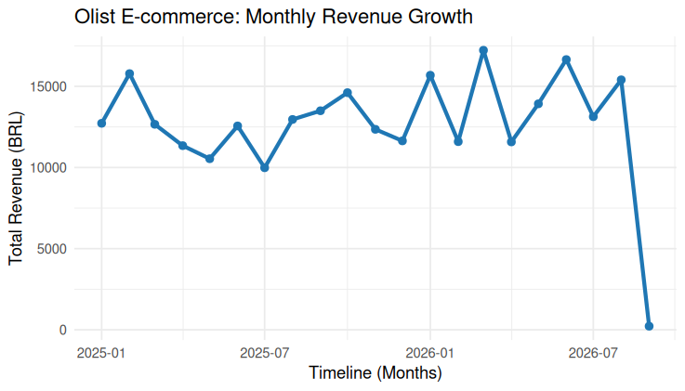
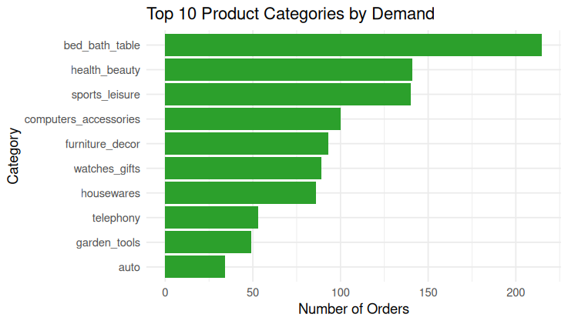
Chart 3: Distribution of Customer Review Scores (Histogram)(Yahan par RStudio se export kiya hua apna Orange color wala Histogram insert/paste karein)R Code Implemented:Rggplot(orders_df, aes(x = review_score)) +
geom_histogram(bins = 5, fill = "#ff7f0e", color = "white", binwidth = 0.5) +
labs(title = "Distribution of Customer Review Scores", x = "Review Score (1-5)", y = "Count of Reviews") +
theme_minimal()
Technical Narrative:This histogram presents the frequency distribution of user ratings. The heavy concentration on 5-star ratings demonstrates high baseline consumer satisfaction. However, minor clusters in low-score metrics signify specific service areas that require optimization.
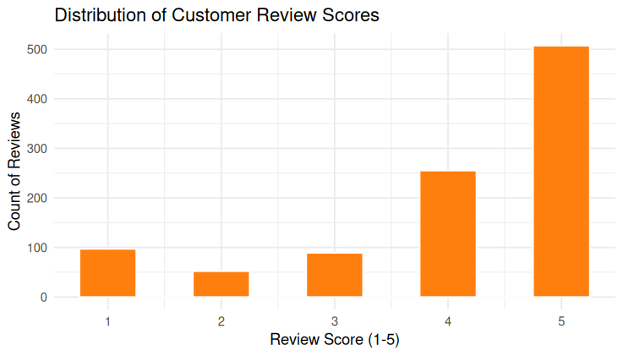
Chart 4: Impact of Delivery Delay on Review Scores (Scatter Plot)(Yahan par RStudio se export kiya hua apna Purple color wala Scatter Plot insert/paste karein)R Code Implemented:Rggplot(orders_df, aes(x = delivery_delay_days, y = review_score)) +
geom_jitter(alpha = 0.4, color = "#9467bd", width = 0.2, height = 0.2) +
labs(title = "Impact of Delivery Delay on Review Scores", x = "Days Delayed", y = "Review Score") +
theme_minimal()
-Technical Narrative:This scatter plot highlights the critical relationship between logistics anomalies (shipping delays) and buyer sentiment. The visible pattern confirms that as shipping delays increase, customer feedback scores drop sharply to 1 or 2 stars. Resolving courier delays is imperative to improving customer retention. 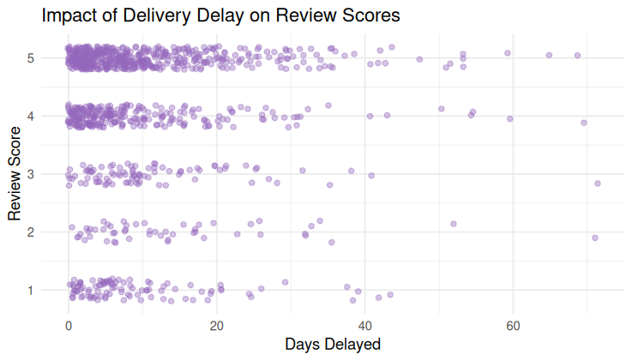

3. Conclusion Week 2 operations successfully visualised raw tabular indices into high-impact operational charts. By converting structural scripts into non-technical narratives, stakeholders can easily identify category priorities and logistics optimization pathways to scale customer satisfaction.

